Ultimate Tanzania Safari Experience

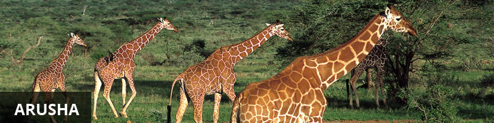
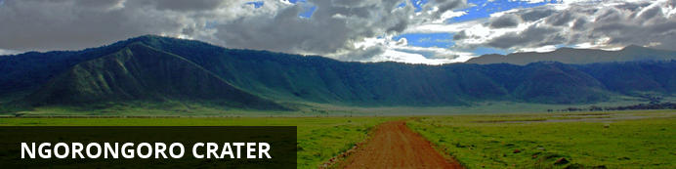
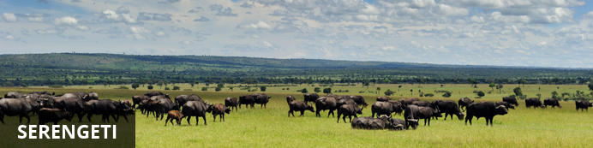
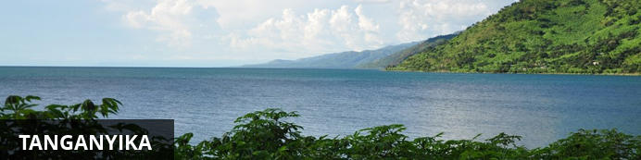
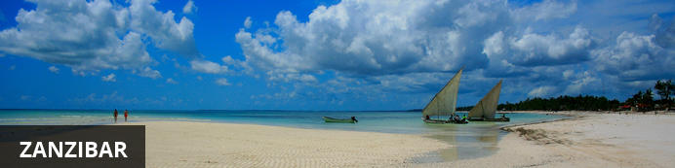

Ultimate Tanzania Safari Experience
Arusha - Ngorongoro - Serengeti - Grumeti - Mahale Mountain - Zanzibar
19 Days / 18 Nights
2 Persons
10 September 2012 - 28 September 2012

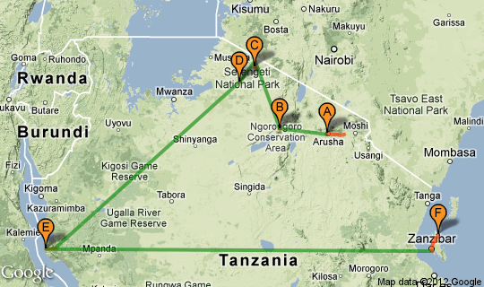

Click here to view your Virtual Itinerary

Overview
An Amazing 19 days Tanzania safari full of unique contrasts combining the best of the Serengeti locations, both in the Northern extremes as well as the western corridor at Singita Grumeti Reserves. Looking to experience The Great Migration, along with the views of the Ngorongoro Crater with the far western beauty of the Mahale Mountains and the shores of Lake Tanganyika for chimpanzee trekking. Ending with the pristine waters off Zanzibar on the private Mnemba Island.

Destination | Accommodation | Nights | Basis | Room Type
Arusha | Legendary Lodge | 1 | D, B&B | 1x Suite
Ngorongoro | Ngorongoro Crater Lodge | 2 | FI | 1x Suite Tree Camp
Serengeti | Serengeti Bushtops Camp | 3 | FI | 1x Tented Suite
Grumeti | Singita Sasakwa Lodge | 4 | FI | 1x 4 Bedroom Retreat
Mahale Mountain | Greystoke Mahale Camp | 4 | FI | 1x Banda
Zanzibar | Mnemba Island Lodge | 4 | FI | 1x Banda

Key
B&B: Bed and breakfast
D, B&B: Dinner, bed and breakfast
FB: Dinner, bed, breakfast and lunch
FB+: Dinner, bed, breakfast, lunch and activities daily
FI: Fully inclusive

Day 1: Arusha (Mon, 10 September)

Arusha
Arusha is the safari capital of Tanzania - nestled below Mt. Meru, close to Mount Kilimanjaro, the Manyara, Tarangire and Ngorongoro National Parks and from there it’s a short trip to the Serengeti. Just to the north, on the slopes of Mt. Meru is the Arusha National Park.
Built by the Germans as a centre of colonial administration because of the temperate climate Arusha is a good spot to take a day or two off from your safari.

Day Description
Suggest arrival in to Kilimanjaro Airport –JRO ( flight own arrangements – suggesting KLM services if schedule, or private jet also a good suggestion as then overnight not required in Arusha).
Meet & assistance with passport control and custom procedures in to Tanzania . – Note: USA Passport holders need a visa to enter Tanzania and can be obtained on arrival for US$100 per person in cash only. Please also be aware Yellow Fever Certificate is also required. Met by a local driver and private safari vehicle for transfer to Legendary Lodge for overnight. Suggest this overnight to counter any jetlag and to rest up ready for the onward safari arrangements – Legendary is certainly the place to do that!

Overnight: Legendary Lodge
Located on the outskirts of Arusha in lush tropical gardens and surrounded by a working coffee farm, we are proud to say that The Legendary Coffee Lodge is one of a kind in Tanzania. Come and enjoy inspiring views of Mount Meru from the privacy of your own garden cottage whilst our staff takes care of your every whim!
The Legendary Coffee Lodge has a variety of luxuriously comfortable accommodation to suit your needs.
Our six garden cottages named Korongo, Kuro, Tandala, Tohe, Nyani and Pala Hala each with a private verandah and stunning views of Mount Meru, make for the perfect place to relax before or after a safari. The interiors have been designed with a unique blend of African arts & crafts combined with Western comforts and old colonial style luxury. Each en suite cottage features comfortable split level living including king size beds with mosquito nets, lounge with fireplace, direct dial phone, broadband connection, complimentary mini-bar & fruit basket and bathrooms each with a bathtub, shower and full range of amenities.
In addition to the garden cottages we have the newly completed two bedroomed Kahawa Cottage which is ideal for a family stay. Additional features of this cottage include a wrap around verandah enclosed in a private garden as well as a fully furnished lounge with satellite television, dining room and kitchenette.
Last but not least, we have Simba and Chui which are two cosy en suite rooms in The Old Farmhouse and are equally comfortable yet conveniently located nearby the dining room and lounge.
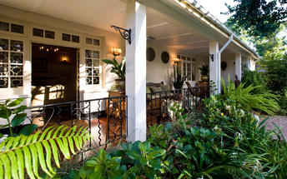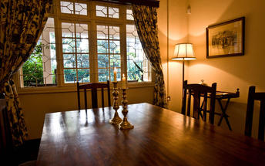

Activities

Included
Dinner, Bed and Breakfast
Drinks (Local Brands)

Recommended

Day 2: Ngorongoro Crater (Tues, 11 September)

Ngorongoro Crater
The Ngorongoro Crater is game viewing gone crazy and it is not surprising that with is one of Tanzania’s major tourist drawcards. Within the crater rim a daily wildlife drama is played out as large herds of zebra and wildebeest graze nearby lions, leopards, elephants and black rhinos. Outside of the crater a similar drama continues in a more spread out manner with Masai herdsmen thrown into the mix.

Day Description
Departure to Arusha airport following breakfast to board your private aircraft for onward departure.
We have included a scenic Kilimanjaro flight around the mountain, which adds an extra 45 min, but will afford you a great visual view of Africa’s highest mountain and an icon of the continent!
Continue onward to Ngorongoro Crater Airstrip ( Note: subject to weather and cloud cover we will land on Crater strip, if not will be Lake Manyara Strip and then drive to Crater Lodge)
On arrival to Ngorongoro Crater airstrip ( subject to weather, or if clouds too low then landing at Lake Manyara airstrip) met by your private guide and 4x4 landcruiser to continue to the famous Ngorongoro Crater Lodge.
After lunch / mid-afternoon ( flexible and all can be discussed with your private guide to suite your requirements), though suggest a scenic drive on the crater rim, visit a local Masai village , enjoy the sun setting over the Crater before returning to the lodge for dinner

Overnight: Ngorongoro Crater Lodge
Ngorongoro Crater Lodge has been called the game lodge at the top of the world and, between the natural riches of the Crater and the amazing architecture, you’ll be truly spoilt. Divided into three camps, 30 stilted suites with banana leaf ceilings and grass roofs provide an intimate and exclusive Crater experience. Each camp has its own sitting and dining areas, with private butlers to provide warm, personal service to each guest. An array of whimsical African touches creates a sumptuous atmosphere that is as elegant and unique as the Crater itself.
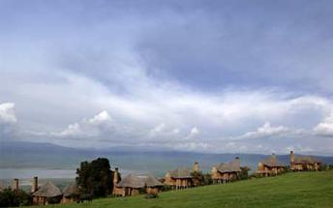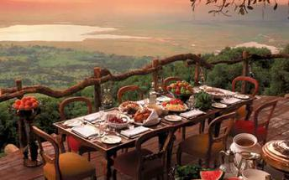

Activities

Included
Bed, All Meals, Most Drinks(local), Fees, Activities
Drinks (Local Brands)

Recommended

Day 3: Ngorongoro Crater (Wed, 12 September)

Day Description
Breakfast at the lodge
Continue with your 4x4 landcruiser down in to the Ngorongoro Crater itself for safari on the crater floor Spectacular Picnic lunch arranged
Ngorongoro Crater is quite possibly the most famous of all Africa’s conservation areas. It is the largest intact volcanic caldera in the world. covering a mere 260km², the 600 meter deep crater is home to a permanent population of more than 30,000 animals, and is one of the only places in Africa where you stand a real chance of seeing the “Big Five” in the course of a morning or evening’s game drive. Unique to the crater are the local Maasai grazing their cattle on the crater floor, sometimes, with a lion kill just a few hundred meters away….
Special inclusions suggest for clients during 2 nights at Crater Lodge
• Maasai village visit at Ngorongoro
• Private picnic lunches in Ngorongoro.
• Maasai dance/warriors guard of honour private dance in Ngorongoro ( private at the lodge for
guests only)
Ngorongoro Crater lodge for dinner and overnight.

Activities

Included
Bed, All Meals, Most Drinks(local), Fees, Activities
Drinks (Local Brands)

Recommended
Ngorongoro Crater
Ngorongoro Crater Lodge Game Drives

Day 4: Serengeti (Thurs, 13 September)

Serengeti
The Serengeti together with Kenya’s Masai Mara Game Park form Africa’s most famous wildlife park. The image of acacia trees on an endless grass plain epitomises Africa for many, and then add a Masai warrior and some cattle to the picture and the conversation need go no further. The annual wildebeest migration through the Serengeti and the Masai Mara is the largest mass movement of land mammals on the planet – with more than a million animals following the rains. But that is not where the game viewing ends; large prides of lions, elephants and giraffes in grasslands, gazelles and eland to mention but a few. Aside from traditional vehicle safaris, hot-air ballooning over the Serengeti plains has become almost essential and you can even do a horseback safari.

Day Description
Breakfast. Drive with 4x4 vehicle to either Ngorongoro Airstrip for collection by private air charter ( *subject to cloud / weather conditions, or otherwise head down the crater to Lake Manyara Airstrip for collection)
Private air charter - Cessna F406 Twin Engine with 2 pilots
Route: Ngorongoro* to Kogatende Airstrip ( for Serengeti Bushtops) Flight time approx. 30 minutes.
Arrival at Kogatende Airstrip where you are met by a new private vehicle and camp ranger from Serengeti Bushtops Camp. Transfer with safari en route to the camp.
Chosen to combine both the northern Serengeti with Singita Grumeti Reserves thereafter to cover the areas where normally the Migration moves through between July – September periods

Overnight: Serengeti Bushtops Camp
Serengeti Bushtops is a 5 star luxury tented camp in the Serengeti National park. The camp is situated in the north western part of Serengeti, Wogakuria 10, near the Mara river and inside the migration corridor. There are 12 tents and 1 family tent all facing the sun downer. Each tent spans over 120 square meters. There is a unique sunken lounge and hot tub as well as 24 hour power and 24 hour butler service. Game drives are conducted in specially converted 4x4's. Activities include full day game drives with pic nics, early morning game drive with bush breakfast, evening game drives with sun downers and walking safaris. Dining is on a la carte basis. The mess tent has a lounge with fire place and library, internet access and a unique bar. Unlimited complimentary massages and laundry service is provided. Nearest airstrip is Kogatende and we provide complimentary transfers to Migori for guests wishing to combine a visit to Mara Bushtops Camp in the Masai Mara.
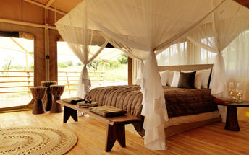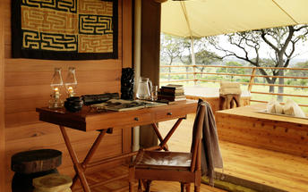

Activities

Included
Bed, All Meals, Most Drinks(local), Fees, Activities
Drinks (Local Brands)

Recommended

Day 5: Serengeti (Fri, 14 September)

Day Description
Breakfast. Full day of safari with private 4x4 vehicle and ranger. Meals and overnight at Serengeti Bushtops Camp.
The northern Serengeti is normally when the Migration moves through between the months of June – September periods ( from Western corridor of the Serengeti to the Northern extremes over the Mara river in to the Masai Mara)
Serengeti Eco-system The name Serengeti stems from the Maasai word "Siring" referring to "endless plains", and that’s really what it is. The Serengeti is vast, stretching from the endless grass plains in the South to the woodlands in the north up to the Kenyan border. The size of the Serengeti eco-system as a whole is virtually the same size as Belgium. The Serengeti hosts the largest concentration of wildlife in the world, thought to be more than 3 million, and is home to one of the great wonders in the world, the Great Migration. Over a million of Wildebeest move annually from the southern plains, where they give birth in December - March, to the north and the Mara River, and back, accompanied by Zebra and other migratory mammals. Lion, cheetah, hyena, hunting dog and crocodiles make sure only the strongest survive.

Activities

Included
Bed, All Meals, Most Drinks(local), Fees, Activities
Drinks (Local Brands)

Recommended

Day 6: Serengeti (Sat, 15 September)

Day Description
Breakfast. Full day of game drives in the area with private 4x4 vehicle and ranger. Meals and overnight at Serengeti Bushtops Camp

Activities

Included
Bed, All Meals, Most Drinks(local), Fees, Activities
Drinks (Local Brands)

Recommended

Day 7: Serengeti (Sun, 16 September)

Serengeti
The Serengeti together with Kenya’s Masai Mara Game Park form Africa’s most famous wildlife park. The image of acacia trees on an endless grass plain epitomises Africa for many, and then add a Masai warrior and some cattle to the picture and the conversation need go no further. The annual wildebeest migration through the Serengeti and the Masai Mara is the largest mass movement of land mammals on the planet – with more than a million animals following the rains. But that is not where the game viewing ends; large prides of lions, elephants and giraffes in grasslands, gazelles and eland to mention but a few. Aside from traditional vehicle safaris, hot-air ballooning over the Serengeti plains has become almost essential and you can even do a horseback safari.

Day Description
Breakfast at camp.
Private air charter in Cessna F406 Twin engine aircraft with 2 pilots from Kogatende to Sasakwa Airstrip ( for Singita Sabora)
Flight time approx. 15 minutes.
Upon arrival at the airstrip collected by 4 x4 Singita vehicle and private guide assigned to you for the duration of your stay .
Arrive for check in at Sasakwa Lodge or Serengeti House
SASAKWA LODGE
The Private Retreat(4 bedrooms) contains a basement nanny flat, which has two twin bedrooms, both en-suite
Each air-conditioned bedrooms, en-suite bathroom with bath and shower, lounge with fireplace, dressing area, a guest toilet, veranda with a Swarovski spotting scope and a heated infinity plunge pool.
Cottages have a personal bar and fridge, electronic safe, direct dial telephone (US lines) and wireless internet access.
Includes: all-suite accommodation, three meals per day, all drinks, including premium wines, spirits and liqueurs (excluding vintage champagne, champagne, and vintage wines on the connoisseurs wine list) and private open Land Rover safaris accompanied by an experienced guide provided for the residence.
Note: In addition to the 4 bedroom residence also now able to offer the exclusive Serengeti House at Sasakwa also offering a private retreat / Villa experience overlooking the sweeping Serengeti Plains.
Lunch at the lodge and afternoon safari in your private 4x4 landrover.
Return to the lodge after sunset for dinner and overnight Sasakwa Lodge.

Overnight: Singita Sasakwa Lodge
Sasakwa Lodge rambles along a rocky promontory perched above the rolling plains. It is among the most deluxe accommodations ever built in East Africa. The entrancing view from on high is an ever-changing tapestry of grasslands, clouds and wildlife as they move across the landscape. The view within of long elegant hallways and inviting sitting rooms is faithful to the architecture and furnishings of the most splendid colonial era homes. Were Karen Blixen, the author of Out of Africa, to arrive at Sasakwa today, she would recognise a spot imbued with the same aesthetic that she lavished on her beloved home in the Ngong hills outside Nairobi.
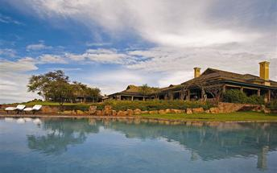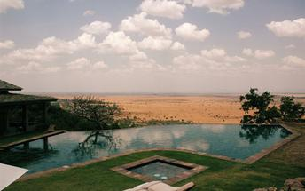

Activities

Included
Bed, All Meals, Most Drinks(local), Fees, Activities
Drinks (Local Brands)

Recommended

Day 8: Serengeti (Mon, 17 September)

Day Description
Breakfast at the lodge
Departing with vehicle for early morning safari with 4x4, returning to the lodge for breakfast / brunch
Time to relax at the lodge, make use of facilities and enjoy a lovely lunch
After lunch time to relax possibly take a bush walk with ranger / guide or make use of spa facilities, or other facilities on offer at Sasakwa Lodge
High tea overlooking the African savannah before embarking on afternoon / evening safari in to the reserve
Enjoy spectacular sundowner drinks overlooking a scenic area your guide will locate to watch the African sun dipping in to the horizon.
Return to the lodge and get ready for dinner

Activities

Included
Bed, All Meals, Most Drinks(local), Fees, Activities
Drinks (Local Brands)

Recommended

Day 9: Serengeti (Tues, 18 September)

Day Description
Breakfast and safari in the reserve in 4x4 landrover.
Lunch at the lodge / villa and relax with activities.
Afternoon depart approx 1500 (flexible) with private helicopter(s) for scenic adventure setting out in the afternoon from Sasakwa, with the setting sun behind you as you fly East to visit to Lake Natron, Mount Oldonyo Lengai ( most active of the Rift Valley Volcanoes), Empakai Crater and early sundowners on the Gol mountains, before returning to Sasakwa lodge at sunset
"Ol Doinyo Lengai" means "Mountain of God" in the language of the native Maasai people
Ol Doinyo Lengai is a volcano located in the north of Tanzania and is part of the volcanic system of the Great Rift Valley in Eastern Africa. It is located in the eastern Rift Valley, south of both Lake Natron and Kenya. It is unique among active volcanoes in that it produces natrocarbonatite lava, a unique occurrence of volcanic carbonatite
Lake Natron is a salt lake located in northern Tanzania, close to the Kenyan border, in the eastern branch of Africa's Great Rift Valley. The lake is fed by the Ewaso Ng'iro River but also by mineral-rich hot springs and is quite shallow, less than three meters (10 feet) deep, and varies in width depending on its water level, which changes due to high levels of evaporation, leaving high levels of salt and other minerals. The surrounding country is dry and receives irregular rainfall.
Temperatures in the lake can reach 50 degrees Celsius (120 degrees Fahrenheit), and depending on rainfall, the alkalinity can reach a pH of 9 to 10.5 (almost as alkaline as ammonia).
Lake Natron in the fore ground and in the distance Oldonyo Lengai
The Empakaai Crater - From the crater rim you have a fantastic view in the craters' green paradise. The caldera is about 6 km wide and nearly half of its floor is covered by a lake. The water in the lake is alkaline and the depth of the lake is about 85m, unusually deep for soda lakes in East Africa. The steep walls of the caldera, clothed in forest, rise in some places to almost 300m above the floor.
The views along the trail downwards are spectacular at every point. All along you can enjoy the changing views of Empakaai itself. In addition, from the northern and eastern side you can look out to the dramatic cone of the still active volcano, Oldoinyo Lengai. If the day is clear, you can look beyond Lengai to the Great Rift Valley and Lake Natron. Sometimes you can even see the distant snows of Kilimanjaro far on the eastern side of the Valley.!
The beauty of the Gol Mountains after rain-awaiting the migration - The Gol Mountains are an ancient and rugged formation rising to the north west of the Ngorongoro Crater highlands. They straddle the Ngorongoro – Stopping in the location for sundowner drinks with the helicopters to end this afternoon scenic flying adventure!
Return back with the helicopters to Sasakwa Lodge for dinner and overnight

Activities

Included
Bed, All Meals, Most Drinks(local), Fees, Activities
Drinks (Local Brands)

Recommended
Ol Donyo Lengai
Lake Natron
Lake Empakaai

Day 10: Serengeti (Wed, 19 September)

Day Description
Breakfast at Sasakwa Lodge
For this day depart with helicopter(s) planned a scenic trip to magical Lake Victoria to the east of Sasakwa
Ideally departure planned around 1000 and return 1500 - 5 hour excursion all in. Note: Helicopter(s) will also need to stop at Mwanza for fuel on the return leg since Rubondo is at the extreme western shore of the lake.
Note: This is a suggested idea that can be accomplished with a helicopter and nice alternative plan, BUT clients prefer then just relax and enjoy normal activities of Sasakwa Lodge and facilities
For this adventure we are planning to take a lovely picnic lunch arranged with hampers from Sasakwa Lodge to carry in the helicopters, and fly east to an area called Rubondo Island, which is on Lake Victoria - Lovely and tropical location! Chimpanzees were introduced to the island in the early 1970's, though we believe they have been left to go wild and are not habituated enough for good sightings, though are around. There is also a beautiful thick tropical forest there which is supposed to be beautiful.
Lake Victoria covers 68,000 square kilometres and is the largest lake in Africa and the second largest in the world – comparatively it is twice the size of The Netherlands.
Rubondo Island National Park - Walking, Boat Excursions, Bird Watching, Fishing, Relaxing...
Rubondo Island, in the southwest of Lake Victoria,is Tanzania’s tenth National Park and the only one in Lake Victoria. The 240 square km island provides a unforgettable experience for visitors, including the main island and 11 smaller islets, combining the breathtaking natural beauty of a forest refuge with the relaxing tranquility of sandylake-shore beaches.
The Island is some 28 km in length along the north-south axis and between 3 and 10 km wide.
Rubondo Island boasts a unique diversity of flora and fauna. Only here can the visitor be sure of seeing Sitatunga and have the chance of observing small gangs of chimpanzees. Other mammals frequently seen include hippos, otters, bushbucks and vervet monkeys. Rarer sightings are genet, colobus, marsh mongoose and suni antelope (dikdik).
Rubondo is a paradise for bird-lovers, with nearly 430 species documented on the island. The diversity of habitats, from open woodland to papyrus swamps and evergreen forest, together with its geographical location in the heart of Africa, attracts numerous resident and migrant species. The islan dhas an abundance of herons, storks,egrets, ibises, cormorants, kingfishers, flycatchers, bee-eaters, hornbills and birds of prey, including the highest density of fish eagles anywhere in the world.
Return back with the helicopters to Sasakwa Lodge for dinner and overnight

Activities

Included
Bed, All Meals, Most Drinks(local), Fees, Activities
Drinks (Local Brands)

Recommended
Lake Victoria

Day 11: Tanganyika (Thurs, 20 September)

Tanganyika
Lake Tanganyika was created by the Great Rift Valley and is the longest and second deepest freshwater lake in the world. The ancient lake is home to more than 350 species of fish.

Day Description
Balloon Ride over Serengeti Plains - Last morning experience with a panorama that is unique to this part of the world, guests looking for something out-of-the-ordinary need look no further than hot-air ballooning over the Serengeti plains.
Game viewing is taken to extraordinary new heights, aerial photography offers a different angle, the freedom of flight is yours and the silent whispers of the breeze entice you on an unforgettable adventure.
You will be collected from your lodge or tented camp and driven to the launch site.
Your pilot will welcome you, give you a full briefing and you’ll watch the inflation of
the hot-air balloon.
Climb aboard and rise as the sun rises to view Africa aloft. The balloon floats in
whichever direction the winds guide while your pilot precisely controls the altitude of
the balloon - sometimes at treetop height, at other times ascending to 1 000 feet to
see the enormity of the reserve.
The Singita Balloon Safari is a romantic and evocative way of experiencing the
wilderness as you gracefully and silently glide over the plains, observing the wide
variety of wildlife below.
The flight is for about an hour, depending on conditions. It has to be the most
beautiful balloon flight in the world, and is a celebration of the best Africa has to
offer.
You’ll arrive back at camp at about 08h30 ready to continue with onward arrangements to next destination
Transfer to Sasakwa airstrip for onward private charter flight to Mahale
Private air charter arranged with Pilatus PC12 Single Engine Pressurized Turbo Prop ( with 2 pilots costed) from Sasakwa ( Singita Sabora) to Mahale
Flight time approx. 1hr and 35 minutes
Note: Use this aircraft as much faster than others and perfect for this route
Upon arrival to Mahale airstrip proceeds to the Camp’s boat for your short cruise on Lake Tanganyika to Greakstoke Mahale

Overnight: Greystoke Mahale Camp
There are few places left on earth that might rightfully be called Eden, and the Mahale Mountains, on the edge of Lake Tanganyika in western Tanzania, is one of them. Your home at Greystoke Mahale is in wildly exotic wooden bandas, looking out across the soft sand beach, with interiors fashioned from old seasoned dhow timber and decorated with style and panache. Life at Mahale is easy in this barefoot paradise. Visit www.nomad-tanzania.com for photos and info.
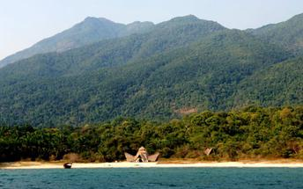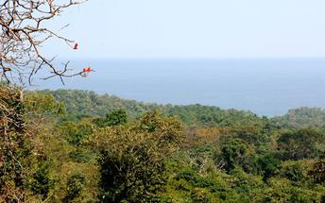

Activities

Included
Bed, All Meals, Most Drinks(local), Fees, Activities
Drinks (Local Brands)

Recommended
Mahale Mountain National Park

Day 12: Tanganyika (Fri, 21 September)

Day Description
Mahale is a pristine, natural experience open to those willing to walk its trails. The birds, primates, monkeys, small predators and butterflies - all signs of life are everywhere and there is little to beat an amble through the forest.
Each day you can venture out into this wonderland to observe the habituated ‘M’ Group as they groom, squabble noisily, or bound into the trees to swing effortlessly between the vines.
As if a day’s chimp trekking wasn’t enough, Boat Safaris, Kayaking, Snorkeling in the shallows along the shore and Fishing excursions are also on offer
Note: Fishing trip can also be included as this part of Lake Tanganyika offers some of the best fresh water fishing in Tanzania. Here you can catch ‘Sangara’ (Nile Perch), ‘Kuhe’ (Yellow Belly) to name just a few.

Activities

Included
Bed, All Meals, Most Drinks(local), Fees, Activities
Drinks (Local Brands)

Recommended

Day 13: Tanganyika (Sat, 22 September)

Day Description
Activities at Greystoke Mahale

Activities

Included
Bed, All Meals, Most Drinks(local), Fees, Activities
Drinks (Local Brands)

Recommended

Day 14: Tanganyika (Sun, 23 September)

Day Description
Activities at Greystoke Mahale

Activities

Included
Bed, All Meals, Most Drinks(local), Fees, Activities
Drinks (Local Brands)

Recommended

Day 15: Zanzibar (Mon, 24 September)

Zanzibar
Spice Island, Slave Island, Arab Island, Tropical Island - Zanzibar is or was all of the above. Today it the tropical beaches and all the romance and attractions that go with them that are the main attraction to this Indian Ocean Island. Scuba diving, snorkelling, deep sea fishing, kayaking, windsurfing, waterskiing and sailing on traditional local dhows are part of the multitude of activities to entertain you, but don’t forget just relaxing on a tropical beach. And if you are looking to do a little exploring the enchanting winding streets and high townhouses of old Stone Town, with their giant, ornate doors, remain unchanged and there are Spice tours to working plantations rich with strong aromas of cloves, vanilla, nutmeg and cinnamon.

Day Description
Breakfast. Boat transfer back to Mahale airstrip.
Depart with onward private air charter with Pilatus PC12 Single Engine Pressurized Turbo Prop ( with 2 pilots costed) from Mahale to Zanzibar
Flight time approx. 2hrs and 25 minutes, again using as much faster and no need to re-fuel using Pilatus PC12 as only aircraft suitable for this route with some degree of speed
Upon arrival in to Zanzibar meet by our local representative and transfer provided to Mnemba Island , off the North Easter tip of Zanzibar. You will be transferred to the Mnemba crossing point (approx. 1 hour drive from the airport) to meet your onward boat transfer to Mnemba Island (approx. 25min).
Note: The arrival and departure point on Mnemba does not have a jetty, so guests have to wade through shallow water and are therefore advised to dress accordingly!

Overnight: Mnemba Island Lodge
Mnemba Island Lodge is a barefoot paradise, where just ten simple but luxurious palm-frond bandas lie hidden in a tropical beach forest fringed by a white beach. Midway between the bandas and the Indian Ocean are shaded traditional Zanzibari ‘beach’ beds, perfect for reading, sleeping, gazing at dhows or doing nothing at all. When it’s time to wash off the sand and salt, a corridor of woven palm leaves leads to a large shuttered bathroom with a massive stone shower behind a glass beaded curtain. Romantic candlelit dinners are served on the beach with the waves gently lapping a few metres away.
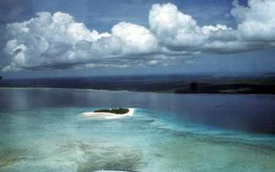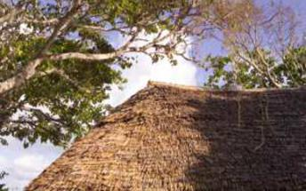

Activities

Included
Bed, All Meals, Most Drinks(local), Fees, Activities
Drinks (Local Brands)

Recommended

Day 16: Zanzibar (Tues, 25 September)

Day Description
At leisure on Mnemba Island including three meals daily, soft drinks, house wines, local beer, local brand spirits, snorkeling, kayaking, salt water fly-fishing, windsurfing and scuba diving (two dives per day for guests holding a valid PADI diving certificate. Alternatively diving courses are available at an additional cost).
Mnemba Island, Zanzibar, | All inclusive private island This is private island off Northern tip of Zanzibar
Mnemba Island Lodge, an award winning jewel is situated on the breathtakingly beautiful private island of Mnemba, a mere 4.5 kilometres (2.8 miles) off of the north–eastern tip of Zanzibar. Mnemba Island Lodge is a beach dreamer’s ultimate paradise experience, surrounded by an atoll of coral reefs in the Indian Ocean. Romantic views, exclusivity and rustic luxury are reason enough to enjoy the unparalleled beauty of this barefoot island paradise.

Activities

Included
Bed, All Meals, Most Drinks(local), Fees, Activities
Drinks (Local Brands)

Recommended
Mnemba Island Lodge Fishing
Mnemba Island Lodge Kayaking
Mnemba Island Lodge Scuba & Snorkel
Mnemba Island Lodge Windsurfing

Day 17: Zanzibar (Wed, 26 September)

Day Description
At leisure on Mnemba Island

Activities

Included
Bed, All Meals, Most Drinks(local), Fees, Activities
Drinks (Local Brands)

Recommended

Day 18: Zanzibar (Thurs, 27 September)

Day Description
At leisure on Mnemba Island

Activities

Included
Bed, All Meals, Most Drinks(local), Fees, Activities
Drinks (Local Brands)

Recommended

Day 19: Zanzibar (Fri, 28 September)

Day Description
Breakfast.
Depending on planned flight out of Zanzibar arrangements made for for late check –out on this final day to ensure rooms can be kept for this day until planned late afternoon departure for the airport
You will be transferred by boat from Mnemba Island to the crossing point (approx. 25min). Here you will be met by a local representative and driven to Zanzibar Airport (approx. 1 hour).. (The arrival and departure point on Mnemba does not have a jetty, so guests have to wade through shallow water and are therefore advised to dress accordingly).
If preferred or for extra interest we can arrange for a private tour of Stone Town and lunch / dinners before transferring to the airport for onward flight out of Zanzibar ( schedule to Dar es Salaam or Private jet aviation collection from Zanzibar)
END OF SERVICES

Activities

Included

Recommended

Transport

Flight Information
Date | Flight | Departure Airport | Time | Arrival Airport | Time | Class | Ref
11 Sep |  | Arusha Airport [ARK] |  | Ngorongoro Airstrip
13 Sep |  | Ngorongoro Airstrip |  | Kogatende Airstrip
16 Sep |  | Kogatende Airstrip |  | Sasakwa Airstrip
20 Sep |  | Sasakwa Airstrip |  | Mahale Mountain National Park
24 Sep |  | Greystoke Mahale Camp |  | Zanzibar International Airport [ZNZ]

Transfers
Date | Pick Up | Drop Off | Time | Vehicle
10 Sep | Kilimanjaro International Airport [JRO] | Legendary Lodge
11 Sep | Legendary Lodge | Arusha Airport [ARK]
11 Sep | Ngorongoro Airstrip | Ngorongoro Crater Lodge
13 Sep | Ngorongoro Crater Lodge | Ngorongoro Airstrip
13 Sep | Kogatende Airstrip | Serengeti Bushtops Camp
16 Sep | Serengeti Bushtops Camp | Kogatende Airstrip
16 Sep | Sasakwa Airstrip | Singita Sasakwa Lodge
20 Sep | Singita Sasakwa Lodge | Sasakwa Airstrip
20 Sep | Mahale Mountain National Park | Greystoke Mahale Camp
24 Sep | Zanzibar International Airport [ZNZ] | Mnemba Island Lodge
28 Sep | Mnemba Island Lodge | Zanzibar International Airport [ZNZ]

